MBARARA UNIVERSITY OF SCIENCE AND TECHNOLOGY
Faculty of Computing and Informatics
Bachelor of Computer Science
FIRE INSURANCE MANAGEMENT SYSTEM (FIMS)
Database Design and Implementation
A Database Management Systems (DBMS) Group Project
Submitted by:
TASHOBYA MARK
Registration No: 2025/BCS/177/PS
May 2026

1. Executive Summary
The Fire Insurance Management System (FIMS) is a relational database application developed using MariaDB/MySQL to automate and streamline fire insurance policy management, claims processing, and financial transactions. This report documents the complete lifecycle of the FIMS project from requirements gathering through to implementation and query testing, in accordance with the DBMS Self-paced Practical Assignment guidelines.

1.1 Project Overview
- FIMS is designed to replace manual, paper-based fire insurance record-keeping with a robust, efficient, and centralized digital database system.
- The system manages eight interlinked relational entities: Customer, Property, Policy, Payment, FireIncident, Claim, Employee, and Renewal.
- All core insurance workflows are supported, including customer registration, property onboarding, policy issuance, premium billing, fire incident logging, claims processing, and policy renewal.
- The database is normalized to Third Normal Form (3NF) to eliminate data redundancy and ensure referential integrity throughout all tables.
- Implementation was done in MariaDB , enforcing foreign key constraints and supporting ACID-compliant transactions.
- A set of eight sample SQL queries was developed and tested to generate key operational and management reports from the live database.
- This report follows the prescribed structure: Business Case, Logical Design, Physical Design, Implementation, and Bibliography.

1.2 Scope of This Report
- Section 2 — Business Case: Application domain, user groups, tangible and intangible benefits, cost analysis, user issues, risk assessment, and system limitations.
- Section 3 — Logical Design: List of entities and attributes, entity relationships, multiplicities, Entity Relationship Diagram (ERD), and user interface dialogue structure.
- Section 4 — Physical Design: MySQL/MariaDB database schema, key design decisions, and description of all queries and reports.
- Section 5 — Implementation: Screenshots of DESCRIBE statements, loaded sample data (SELECT *), and sample query results.
- Section 6 — Bibliography: All referenced textbooks, online resources, and real-world comparable systems consulted.

2. Business Case
This section presents the justification for developing the Fire Insurance Management System (FIMS), covering the domain of application, the benefits the system delivers, costs involved, user considerations, identified risks, and the known limitations of the current version.

2a. Application Domain
FIMS operates within the Property and Casualty (P&C) Insurance sector, specifically targeting fire hazard coverage for residential, commercial, and industrial properties in Uganda.
- The system supports all major business processes of a fire insurance company, including customer onboarding, property registration, policy creation, premium billing, incident reporting, and claims processing.
- It manages structured data about insured properties — including property type (residential, commercial, or industrial), geographic location, year built, size in square metres, and declared monetary value.
- Insurance agents use the system to create, update, and renew policies, search customer records by name or ID, and update policy terms without requiring paper files or manual cross-referencing.
- Claims officers use the system to link recorded fire incidents to existing active policies, compute claim amounts based on the coverage percentage in the policy, and track the status of each claim from 'Pending' through 'Approved' or 'Rejected'.
- Administrative and finance staff use the system for premium billing — recording payments, generating invoice summaries, tracking payment history per policy, and flagging policies with overdue premiums.
- Management personnel access built-in query reports to monitor key performance indicators (KPIs) such as total premiums collected by period, number of pending claims, the overall loss ratio, and portfolio exposure by geographic location.
- The system is modeled on the standard insurance operational lifecycle: quotation → policy issuance → premium collection → incident recording → claim filing → claim settlement → policy renewal.
- Real-world comparable systems consulted during domain analysis include Jubilee Insurance Uganda and UAP Old Mutual Uganda, both of which operate fire insurance product lines serving similar customer segments in East Africa.
- The system is designed for a single insurance branch in its first version (V1.0), with the architecture allowing future scaling to multiple branches or a centralized national database.

Key User Groups
User Group | Primary Responsibilities | System Access Level
Insurance Agents | Register customers and properties, issue policies, process renewals, update policy terms | Customer, Property, Policy, Renewal tables
Claims Officers | Record fire incidents, link incidents to policies, process claims, update claim status | FireIncident, Claim, Policy tables
Admin / Finance | Record premium payments, generate billing summaries, flag overdue accounts | Payment, Policy tables
IT / DBA | Maintain database schema, perform backups, manage user permissions and access control | Full database access
Management | View KPI dashboards, review loss ratios, approve large claim settlements | Read-only reporting queries

2b. Analysis of Benefits
The following tangible and intangible benefits justify the development and deployment of FIMS:

Tangible Benefits
- Elimination of paper-based filing reduces stationery, printing, and physical storage costs by an estimated 65–70%, freeing office space and reducing administrative overhead.
- Faster policy issuance — digital workflows reduce policy creation time from 1–2 business days to under 15 minutes, improving agent productivity and customer experience.
- Elimination of manual data entry errors through enforced data types, NOT NULL constraints, ENUM validation, and foreign key referential integrity checks at the database level.
- Faster retrieval of historical claim data — any customer record, policy history, or past claim can be retrieved in under 2 seconds via indexed queries, compared to hours with physical filing systems.
- Automated premium calculations based on property declared value and coverage percentage reduce billing errors and disputes between customers and the company.
- Reduced claim processing time — linking fire incidents to active policies electronically removes the need for manual cross-referencing of paper files by claims officers.
- Lower staffing overhead for record management — fewer clerical staff are needed for filing, retrieval, and manual calculations once the system is in operation.
- Automated renewal alerts — the system can identify policies expiring within 30 days via a simple SQL query, enabling proactive customer contact and reducing policy lapse rates.

Intangible Benefits
- Improved customer trust and satisfaction through faster claim settlement turnaround and the ability to provide accurate, real-time policy status updates.
- Better data security — electronic records with role-based user access control are significantly harder to tamper with, misplace, or destroy than physical paper files.
- Enhanced management oversight — real-time SQL reports on premiums, claims, and portfolio exposure provide accurate, on-demand information without manual compilation.
- Improved regulatory compliance — structured, auditable records simplify annual reporting to the Insurance Regulatory Authority of Uganda (IRA) and facilitate external audits.
- Scalability — the normalized relational database can be extended in future versions to support additional peril types (flood, theft, earthquake), additional branches, or integration with mobile money payment APIs.
- Competitive advantage — faster service delivery and reduced errors improve the company's reputation and customer retention in a competitive insurance market.
- Environmental sustainability — reduction in paper consumption aligns with green business practices and reduces the organization's carbon footprint.
- Foundation for future analytics — well-structured relational data can power BI dashboards, trend analysis tools, and AI-based risk scoring models in future versions.

2c. Analysis of Costs
- Software costs: Minimal — MariaDB and phpMyAdmin are open-source and free to download and deploy, eliminating licensing fees that would otherwise apply to commercial database systems.
- Hardware costs: Costs may be incurred for purchasing servers or using cloud hosting services
- Development costs: Estimated 80–120 hours of database developer and analyst time for requirements analysis, schema design, implementation, testing, and documentation; primarily a one-time cost.
- Training costs: Role-specific staff training estimated at 2 days per user group; costs include trainer fees, printed quick-reference guides, and time away from normal duties during the training period.
- Data migration costs: Existing paper records must be converted into digital records
- Maintenance and support costs: Regular system updates, backups, and technical support are required.
- Network infrastructure costs: A local area network (LAN) connection is required for multi-user concurrent access; internet connectivity may also be required for cloud backups or remote access by manage.

2d. User Issues — Skills, Adoption, and Training
- Most insurance company staff have basic computer literacy skills (familiarity with MS Office, email, and smartphones) but limited direct experience with database management interfaces such as phpMyAdmin or SQL command lines.
- A user-friendly graphical interface (web form or desktop application) front-end is recommended for V2 of the system to lower the skill barrier and make the system accessible to non-technical staff.
- The adoption effort is moderate: because FIMS workflows are designed to mirror existing paper-based insurance processes, the conceptual learning curve for most staff is manageable within 2–3 training days.
- Initial resistance to change is expected, particularly from senior staff with many years of experience using manual filing systems — structured change management communication, leadership endorsement, and demonstrations of time-saving benefits are essential.
- Training must be role-specific: insurance agents should focus on customer registration, property entry, and policy creation workflows; claims officers on incident recording and claim processing; finance staff on payment recording; managers on reading and interpreting query reports.
- Quick-reference laminated cards summarizing the most common database operations should be prepared for each role and placed at workstations to reduce dependency on the trainer after initial training.
- A phased rollout strategy — beginning with a pilot at one branch or department — is recommended before full system deployment to identify unexpected issues and gather user feedback without disrupting the entire organization.
- Ongoing quarterly refresher training sessions should be scheduled for the first year to reinforce good data entry habits, cover system updates, and address staff turnover.

2e. Risk Assessment
Risk | Category | Likelihood | Mitigation Strategy
Data loss due to server hardware failure | Technical | Medium | Automated daily backups to an off-site location or cloud storage; tested monthly restore procedure
Unauthorized access to sensitive customer data | Security | Medium | Implement role-based access control with strong password policies and user-level permissions per database table
Network downtime disrupting multi-user access | Technical | High | Local caching mechanism for offline data entry to be implemented in V2; critical lookups cached locally
Staff resistance to digital system adoption | Organizational | Medium | Executive-level change management communication; role-specific benefits demonstration; phased rollout
Inaccurate or incomplete data entry by staff | Operational | High | Database-level input validation (NOT NULL, ENUM, CHECK constraints); mandatory fields; periodic data quality audits
Scope creep during development phase | Project | Low | Clearly defined V1.0 scope agreed upfront; formal change request process required for any additions
Loss of data during migration from paper records | Operational | Medium | Supervised data entry with two-person verification; random sample auditing of migrated records against source documents

2f. System Limitations
- Version 1.0 of FIMS handles only fire hazard perils — multi-peril policies covering flood, theft, earthquake, or liability are not supported in the current schema design and would require schema extensions in a future version.
- There is no dedicated graphical user interface (GUI) in V1.0 — all interactions occur via SQL queries in the MariaDB command line interface or phpMyAdmin, which requires basic SQL literacy from system users.
- The system does not currently integrate with external platforms such as the Insurance Regulatory Authority of Uganda (IRA) reporting portal, mobile money payment gateways (MTN MoMo, Airtel Money), or banking APIs.
- No automated fraud detection logic is implemented — suspicious patterns such as repeated claims on the same property within a short period must be identified and flagged manually by claims officers reviewing reports.
- The current design does not support document attachments (for example, scanned claim forms, property ownership documents, or fire incident photographs) — a file storage system linked to the database would be required in V2
- Reporting is limited to the eight predefined SQL queries developed for this project — no ad hoc query builder, drag-and-drop reporting dashboard, or data export to Excel/PDF is available in V1.0.
- The system is designed for single-currency operation in Ugandan Shillings (UGX) — multi-currency support for international policies or foreign reinsurance transactions would require additional schema fields and conversion logic.
- User authentication, session management, and audit trail logging (recording who made which changes and when) are not implemented at the database layer in V1.0 and are strongly recommended before any production deployment.

3. Logical Design
This section presents the logical data model for FIMS, including the identified entities and their attributes, the relationships between entities with their multiplicities, a comprehensive Entity Relationship Diagram, and the user interface dialogue structure for the primary system workflow.

3a. List of Entities
- Customer — represents an individual person or corporate organization that holds one or more fire insurance policies with the company.
- Property — represents a specific physical asset (a building or structure) owned by a customer that is registered and covered under a fire insurance policy.
- Policy — represents the formal insurance contract issued between the insurance company and a customer, covering a specific property for a defined period.
- Payment — represents each individual premium payment transaction made by a customer against an active policy, including the amount, date, and payment method.
- FireIncident — represents a recorded fire event that occurred at an insured property, including the date, cause, and assessed level of damage.
- Claim — represents a formal compensation request submitted by the customer (or agent on their behalf) following a fire incident at an insured property.
- Employee — represents a member of company staff (insurance agent, claims officer, or administrator) who uses the system to perform operational tasks.
- Renewal — represents the formal renewal of an existing insurance policy at the end of its coverage period, creating a new coverage term and premium amount.

3b. Entities and Their Attributes
Entity | Primary Key | Key Attributes
Customer | customer_id | first_name, last_name, phone, email, address
Property | property_id | customer_id (FK), type, location, value
Policy | policy_id | property_id (FK), coverage, premium, status
Payment | payment_id | policy_id (FK), date, amount, method
FireIncident | incident_id | property_id (FK), date, cause, damage_level
Claim | claim_id | policy_id (FK), incident_id (FK), date, amount
Employee | employee_id | employee_name, role, contact
Renewal | renewal_id | policy_id (FK), renewal_date, amount

3c & 3d. Entity Relationships and Multiplicities
All relationships in FIMS are binary (involving exactly two entities). No unary, ternary, or quaternary relationships were identified as applicable to this domain. The table below summarizes each relationship with its type and multiplicity:

Relationship | Type | Multiplicity | Business Rule / Justification
Customer → Property | Binary | 1 : N | One customer may own and insure multiple properties in different locations
Property → Policy | Binary | 1 : N | One property may be covered by multiple successive policies over time (renewals or re-issuance)
Policy → Payment | Binary | 1 : N | One policy generates multiple payment records (monthly or annual premium instalments)
Property → FireIncident | Binary | 1 : N | One property may suffer multiple separate fire incidents across its insurance history
FireIncident → Claim | Binary | 1 : 1 | Each unique fire incident generates exactly one claim for audit clarity and to prevent duplicate claims
Policy → Claim | Binary | 1 : N | One policy can be associated with multiple claims across different fire incidents over the policy lifetime
Policy → Renewal | Binary | 1 : N | One policy can be renewed multiple times, each renewal extending the coverage to a new end date
Employee → Renewal | Binary | 1 : N | One employee (insurance agent) can process many policy renewals across their work history

3e. Entity Relationship Diagram (ERD)
The ERD below was designed using LucidChart and uses Crow's Foot notation to represent all 8 entities, their primary and foreign keys, all attributes, and all relationship lines with multiplicities.

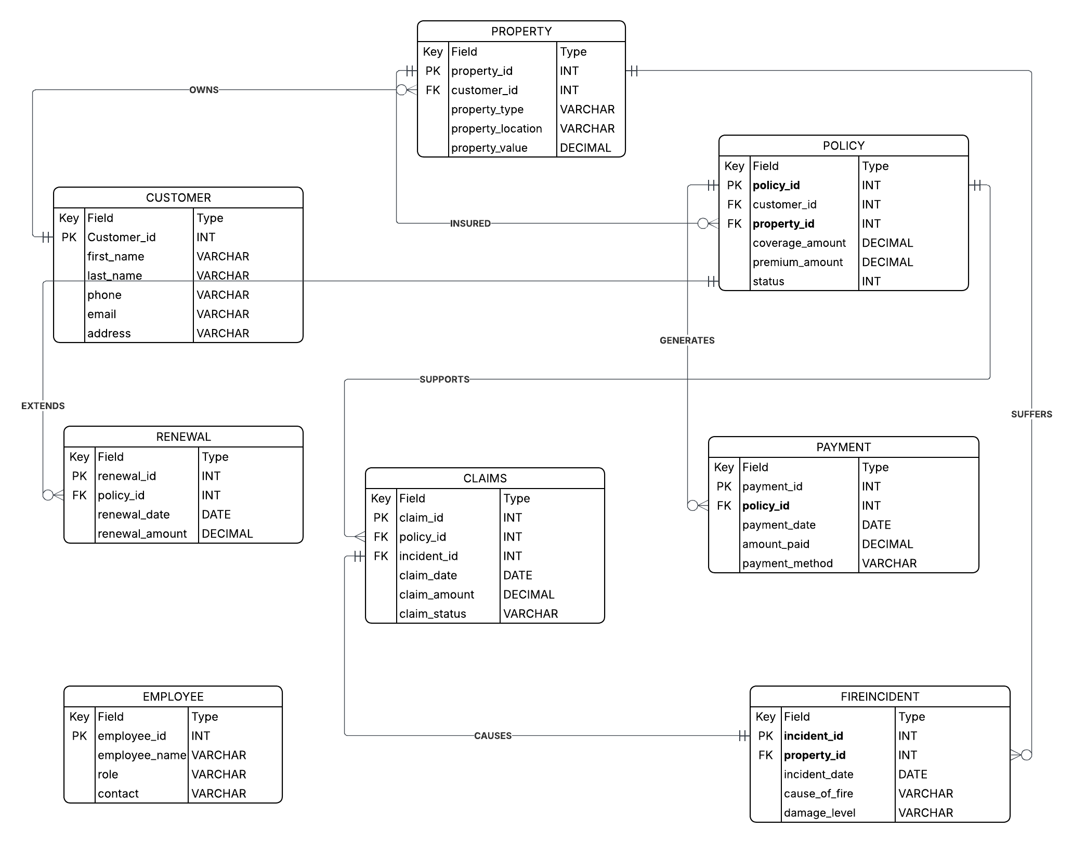
Figure 1: Entity Relationship Diagram for FIMS (Crow's Foot Notation)

3f. User Interface — Dialogue Structure
The primary user workflow in FIMS is issuing a new fire insurance policy. The dialogue structure below describes the sequential steps a user follows from login to policy confirmation:

Step | Screen / Action | Description
1 | User Login | User enters username and password; system validates credentials and assigns role-based access permissions (agent, claims officer, admin, or management)
2 | Search / Add Customer | Agent searches for an existing customer by name or ID; if new, enters full customer details: first name, last name, phone number, email address, and physical address
3 | Register Property | Agent enters full property details: property type (residential/commercial/industrial), physical location, declared monetary value, year built, and size in square metres
4 | Define Policy Terms | Agent selects coverage amount, system calculates premium (based on declared value × premium rate), sets policy start and end dates, and assigns policy status as 'Active'
5 | Process Initial Payment | Finance staff records the first premium payment: amount, payment method (cash, mobile money, or bank transfer), transaction reference number, and payment date
6 | System Confirmation | System generates a unique policy number, stores all related records across Customer, Property, Policy, and Payment tables, and displays a summary confirmation to the agent

4. Physical Design

4g. Database Schema — MySQL / MariaDB
The physical schema implements all eight entities as relational tables in MariaDB, using the InnoDB storage engine to enforce foreign key constraints and support ACID-compliant transactions. The schema screenshot from MariaDB Designer below shows all linked tables and their foreign key relationships:
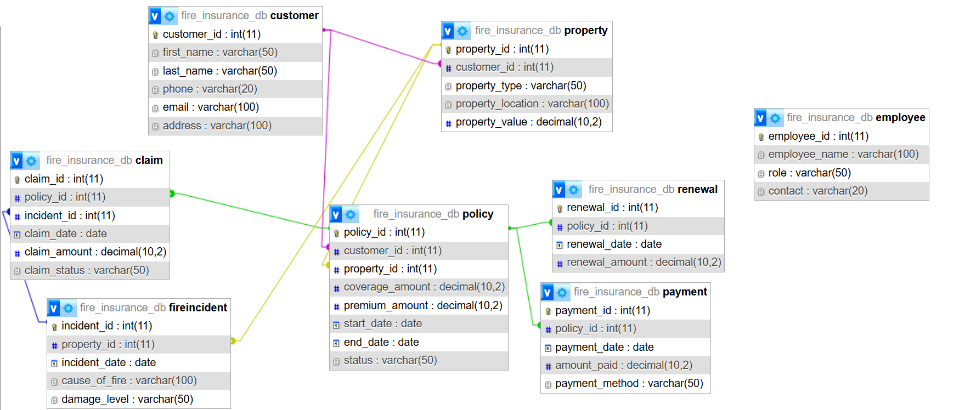
Figure 2: Physical Database Schema in MariaDB showing FK Relationships

Key Physical Design Decisions
The physical design focused on ensuring data integrity, efficiency, and proper storage of insurance records.
- The InnoDB storage engine was used for all tables because it supports foreign keys and transaction management, which helps maintain data consistency.
- Primary keys were created using INT AUTO_INCREMENT to ensure every record has a unique identifier.
- Appropriate VARCHAR sizes were selected for fields such as names, emails, addresses, and reference numbers to optimize storage.
- Financial fields such as premium payments, coverage amounts, and claims were stored using DECIMAL(15,2) to ensure accurate monetary calculations.
- All date-related information such as policy dates, payment dates, and incident dates used the DATE data type.
- ENUM fields were used for categories like policy status, claim status, property type, and payment methods to restrict invalid entries.
- Foreign key constraints were implemented to maintain relationships between tables.

Importance:
These design decisions improve:
- Data accuracy
- Security
- Consistency
- Database performance
- Reliability of insurance operations

4h. Description of Queries and Reports
The system includes important queries that support operational and management decision-making in the fire insurance company.

Query 1: Pending Claims Report
Shows all pending claims along with customer details and claim amounts.
Purpose:
Helps claims officers monitor unresolved claims and process them faster.

Query 2: Total Premium Revenue Report
Calculates total premium payments collected within a given period.
Purpose:
Helps finance teams monitor company revenue.

Query 3: Expiring Policies Report
Shows active policies that are close to expiration.
Purpose:
Helps agents contact customers for renewals.

Query 4: High-Risk Properties Report
Identifies properties with repeated fire incidents.
Purpose:
Helps management assess risk and adjust insurance decisions.

Query 5: Customer Policy Portfolio Report
Displays customer policies, property values, and premium totals.
Purpose:
Helps identify high-value customers.

Query 6: Loss Ratio Analysis Report
Compares total claims paid against premiums collected.
Purpose:
Helps management evaluate company profitability.

Query 7: Employee Productivity Report
Shows how many renewals each employee has processed.
Purpose:
Helps management evaluate staff performance.

Query 8: Premium Payment Defaulters Report
Identifies customers who have delayed premium payments.
Purpose:
Helps finance teams follow up on overdue payments.

5. Implementation
This section presents evidence of the physical implementation of FIMS in MariaDB, including table structure screenshots, sample loaded data, and results of the sample queries executed against the live database.

5.1 Table Structure — DESCRIBE Statements
The following screenshots confirm the physical structure of the core database tables as implemented in MariaDB, showing field names, data types, null constraints, key types, and default values:

DESCRIBE customer;
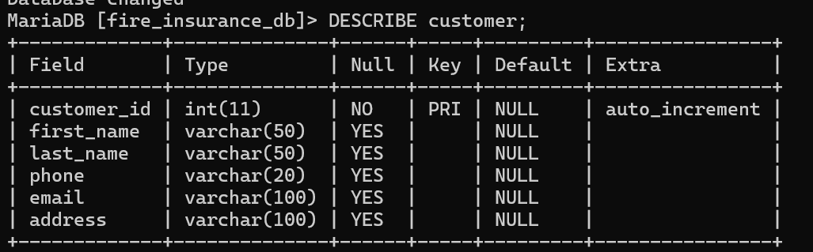

DESCRIBE property;
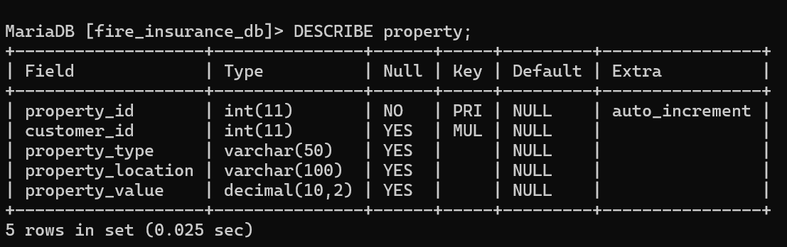

DESCRIBE policy;
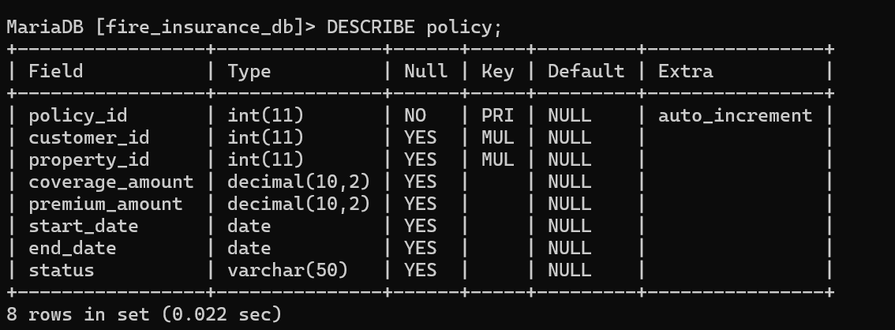

DESCRIBE claim;
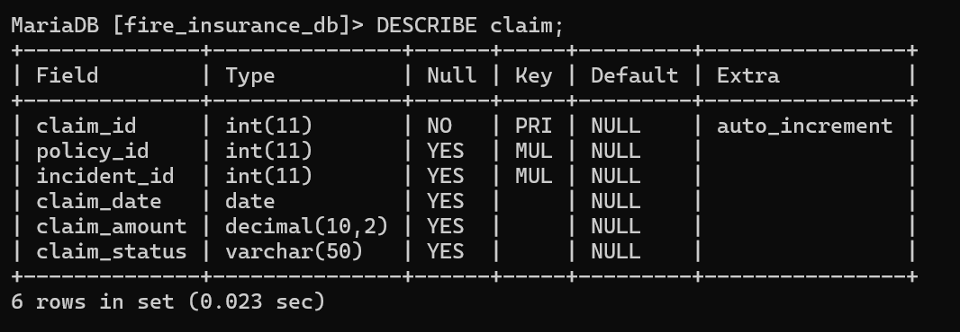

5.2 Sample Data — SELECT * Results

SELECT * FROM claim;
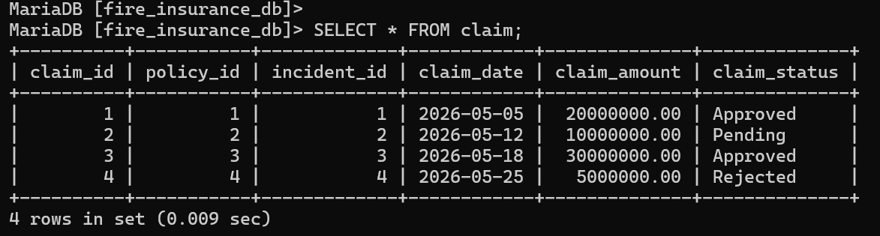

5.3 Sample Query Results
The following screenshots show the results of the sample queries executed against the live MariaDB database after loading sample data:

Query 1 Result: View Active Policies
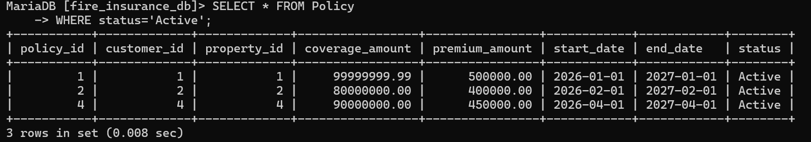

Query 2 Result: View All Claims
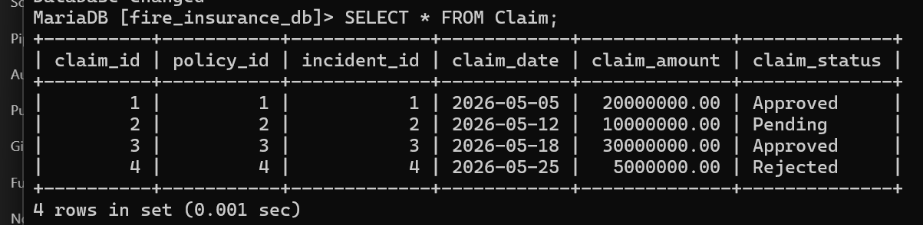

Query 3 Result: View Renewals
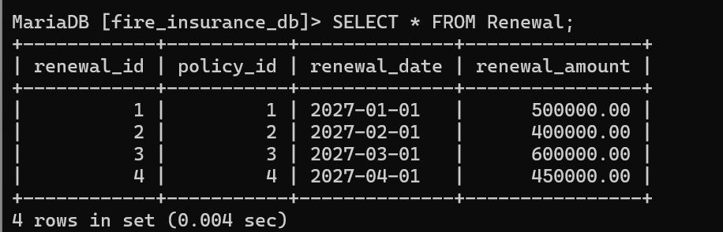

6. Bibliography
- MariaDB Foundation (2024). MariaDB SQL Language Reference. Used for SQL commands and database implementation.
- Lucidchart (2024). Guide to Database Design and Entity Relationship Diagrams. Used for creating ER diagrams and understanding relationships.
- Mbarara University of Science and Technology (2026). Database Management Systems Practical Assignment Guidelines. Used as the main project guideline document.
- Jubilee Insurance Uganda (2024). Fire Insurance Policy Terms and Conditions. Used to understand real-world fire insurance operations.
- W3Schools (2024). MySQL Tutorial. Used for SQL syntax and query examples.

